**Morning:**

Get up in the 7:35 a.m.

a [quick slice of toast](https://www.bordbia.ie/industry/manufacturers/insight/publications/bbreports/RecentMarketingReports/The-Breakfast-Club-Report-April-2016.pdf) is the number one option, followed by cereal, then eggs. And of course, it's usually always washed down with a cup of tea.

Commute to work or gym.

**Noon:**

Maybe just sandwiches with soup

**Afternoon:**

Premier League

**Evening:**

Happy hour with friends or colleagues

**Night:**

TV shows- Game of Thrones

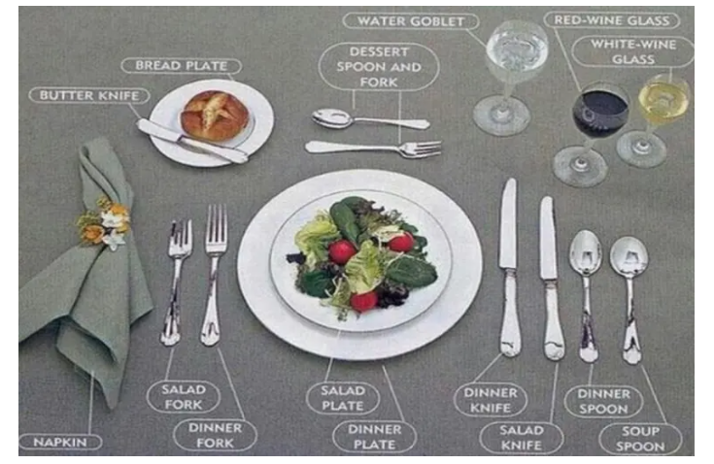

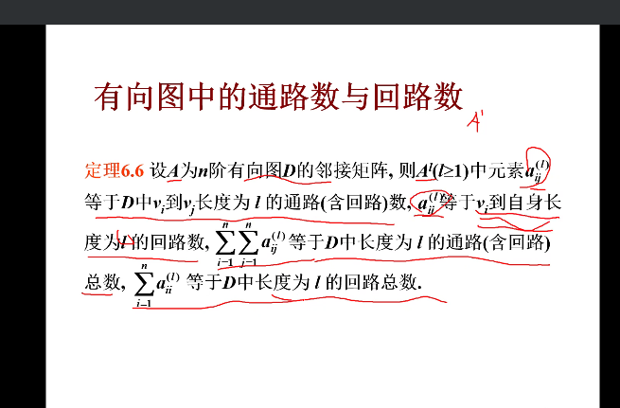

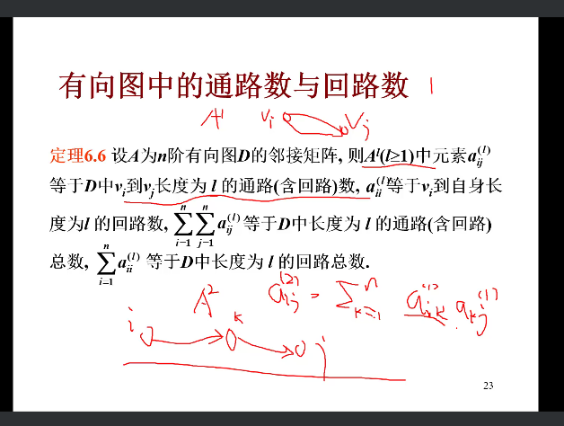

For example, if this lunch starts at 11:30 am you must arrive before 11:30 am. So, plan ahead and make sure your 'late arrivals' are kept to a minimum.

U know, it’s now winter to spring , so u may wear jacket or coat right,

If you want to take off, Just give it to the waiter.

But never hang it on the back of your chair.

If you have not finished eating,

cross your knife and fork.

Indicate you have finished eating by laying your knife and fork paralleled with changed position.

This picture shows the placement of tableware in a formal western-style restaurant.

This may take some time to get well familiar with them.So we will not talk about it here.

Use your napkin or ask the waiter for sparkling water.

If you burp, it’s not a big deal, just cover your mouth with your napkin.

After it happens, say a quiet "pardon me" to no one in particular, do not make a big deal about it.

If you get some food stuck between your teeth do not use fingernails, or napkins to dislodge the food. If necessary go to the bathroom and take care of it.